Retrieval Augmented Generation

## 1.1 Steps of a RAG System

1. **User Submits Query:** User inputs a query.
2. **RAG System Queries Relevant Documents:** RAG searches for relevant documents.
3. **Document Database Returns Documents:** Database returns the documents.
4. **Combine the Query & Documents:** RAG combines documents with the original query.
5. **LLM Returns Answer:** Combined query and documents are sent to an LLM.
6. **RAG System Returns Answer to User:** Answer is returned to the user.

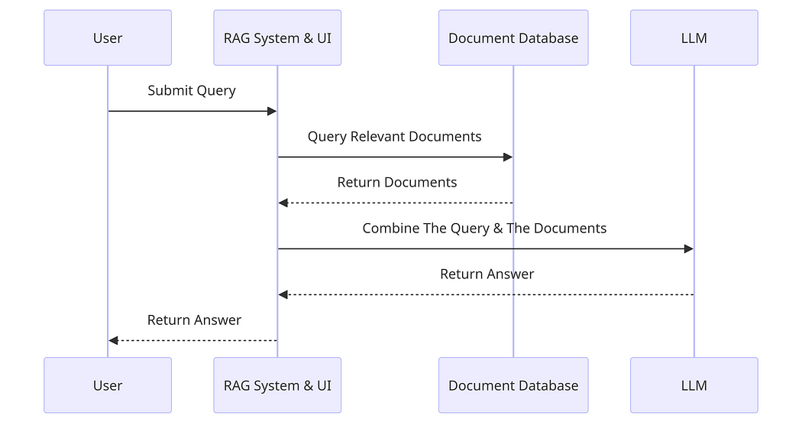

## 1.2 How to Query Documents

### Inserting to DB:

1. **Read Docs from Source:** RAG reads documents.
2. **Chunk Function:** Documents are broken into smaller chunks.
3. **Return Chunks:** Chunk function returns smaller chunks.
4. **Embedding Function:** Chunks are converted into embeddings (vectors).
5. **Store Vectors in DB with Metadata:** Vectors and metadata are stored in a vector database.

### Retrieving from DB:

1. **User Submits Query:** User submits a query.
2. **Embedding Function:** Query is converted into an embedding vector.
3. **Search Similar Vectors in DB:** Query vector is used to search for similar vectors.
4. **DB Returns Vectors:** Database returns the most similar vectors.

## Requirements

1. **AWS Services:**
   * S3: store document data.
   * SageMaker: Jupyter Notebooks and model deployment.
   * DynamoDB/Elasticsearch: document storage and retrieval.
   * IAM Roles: permissions and security.
2. **Claude LLM Access:** Claude API.
3. **Python Libraries:** boto3, requests.

## Workflow

1. **Data Preparation:**
   * Store documents in S3.
2. **Document Ingestion:**
   * Use SageMaker notebooks to process documents.
   * Chunk documents and generate embedding.
   * Store embeddings and metadata in DynamoDB.
3. **Query Handling:**
   * User submits a query via SageMaker notebook interface.
   * Convert query to an embedding.
   * Retrieve relevant document embeddings from DynamoDB.
   * Combine query and documents for LLM input.
4. **Claude LLM Interaction:**
   * Send the combined input to Claude API.
   * Receive the generated response.
5. **Response Delivery:**
   * Display the response in the SageMaker notebook.